Practice 9.1.1
Write a program that takes a string as input and prints the total count of vowels in that string. Consider both uppercase and lowercase.

Algorithm:-
Step 1: Start
Step 2: Read a string s from the user
Step 3: Initialize a counter variable count = 0
Step 4: Define the set of vowels as "aeiouAEIOU"
Step 5: For each character ch in the string s, repeat Steps 6–7:
Step 6: Check if ch is present in the vowels string
If Yes → go to Step 7
If No → go back to Step 5 (next character)
Step 7: Increment count by 1 (i.e., count = count + 1)
Step 8: After all characters are processed, print the value of count
Step 9: Stop
FlowChart:-
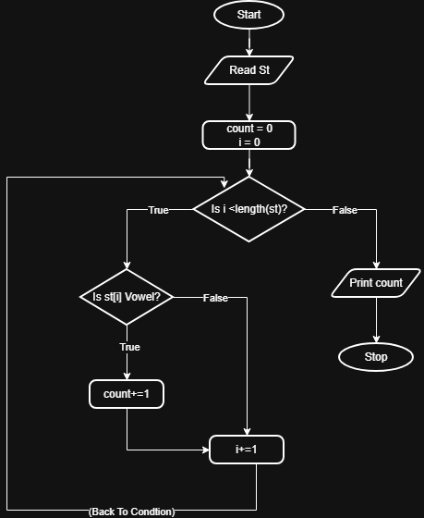

Code:-
